Globalisation

Table of content
- Introduction of globalization
- Controversy about the Globalization
- Present scenario (In India or globally both)
- Effect of Globalization on India's Economic Growth
4.1 Quantitative Analysis
- Future of the Globalization
- Benefits of globalization
- Disadvantage of globalization
- Recommendation
- Conclusion
10. References and bibliography

1. Introduction
Globalization is a process of interaction and integration among the people, companies, and governments of different nations, a process driven by international trade and investment and aided by information technology. This process has effects on the environment, on culture, on political systems, on economic development and prosperity, and on human physical well-being in societies around the world.

Globalization is not new, though. For thousands of years, people—and, later, corporations— have been buying from and selling to each other in lands at great distances, such as through the famed Silk Road across Central Asia that connected China and Europe during the Middle Ages. Likewise, for centuries, people and corporations have invested in enterprises in other countries. In fact, many of the features of the current wave of globalization are similar to those prevailing before the outbreak of the First World War in 1914.

But policy and technological developments of the past few decades have spurred increases in cross-border trade, investment, and migration so large that many observers believe the world has entered a qualitatively new phase in its economic development. Since 1950, for example, the volume of world trade has increased by 20 times, and from just 1997 to 1999 flows of foreign investment nearly doubled, from $468 billion to $827 billion. Distinguishing this current wave of globalization from earlier ones, author Thomas Friedman has said that today globalization is "farther, faster, cheaper, and deeper."

This current wave of globalization has been driven by policies that have opened economies domestically and internationally. In the years since the Second World War, and especially during the past two decades, many governments have adopted free-market economic systems, vastly increasing their own productive potential and creating myriad new opportunities for international trade and investment. Governments also have negotiated dramatic reductions in barriers to commerce and have established international agreements to promote trade in goods, services, and investment. Taking advantage of new opportunities in foreign markets, corporations have built foreign factories and established production and marketing arrangements with foreign partners. A defining feature of globalization, therefore, is an international industrial and financial business structure.
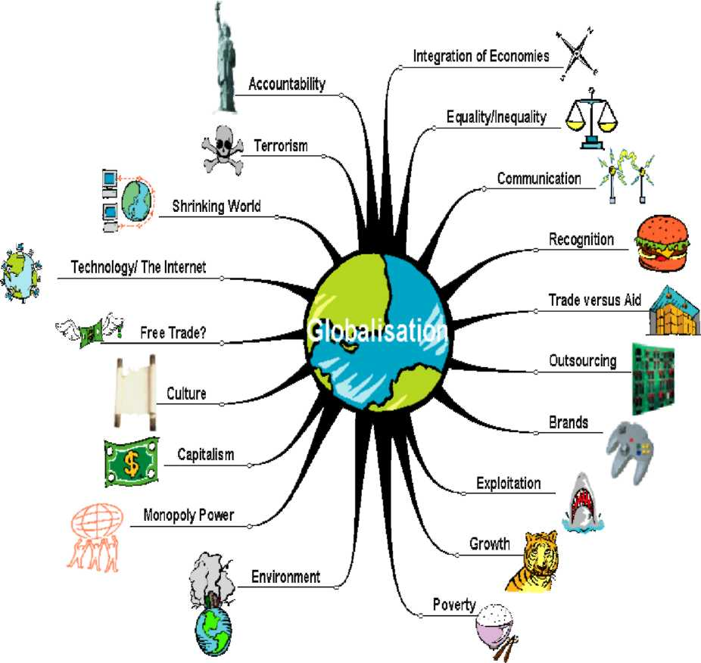

Technology has been the other principal driver of globalization. Advances in information technology, in particular, have dramatically transformed economic life. Information technologies have given all sorts of individual economic actors—consumers, investors, businesses—valuable new tools for identifying and pursuing economic opportunities, including faster and more informed analyses of economic trends around the world, easy transfers of assets, and collaboration with far-flung partners.

Globalization is deeply controversial, however. Proponents of globalization argue that it allows poor countries and their citizens to develop economically and raise their standards of living, while opponents of globalization claim that the creation of an unfettered international free market has benefited multinational corporations in the Western world at the expense of local enterprises, local cultures, and common people. Resistance to globalization has therefore taken shape both at a popular and at a governmental level as people and governments try to manage the flow of capital, labor, goods, and ideas that constitute the current wave of globalization.
There are countless indicators that illustrate how goods, capital, and people, have become more globalized.
The value of trade (goods and services) as a percentage of world GDP increased from 42.1 percent in 1980 to 62.1 percent in 2007.

Foreign direct investment increased from 6.5 percent of world GDP in 1980 to 31.8 percent in 2006.

The stock of international claims (primarily bank loans), as a percentage -of world GDP, increased from roughly 10 percent in 1980 to 48 percent in 2006.

The number of minutes spent on cross-border telephone calls, on a per-capita basis, increased from 7.3 in 1991 to 28.8 in 2006.

The number of foreign workers has increased from 78 million people (2.4 percent of the world population) in 1965 to 191 million people (3.0 percent of the world population) in 2005.

The growth in global markets has helped to promote efficiency through competition and the division of labor—the specialization that allows people and economies to focus on what they do best. Global markets also offer greater opportunity for people to tap into more diversified and larger markets around the world. It means that they can have access to more capital, technology, cheaper imports, and larger export markets. But markets do not necessarily ensure that the benefits of increased efficiency are shared by all. Countries must be prepared to embrace the policies needed, and, in the case of the poorest countries, may need the support of the international community as they do so.
The broad reach of globalization easily extends to daily choices of personal, economic, and political life. For example, greater access to modern technologies, in the world of health care, could make the difference between life and death. In the world of communications, it would facilitate commerce and education, and allow access to independent media. Globalization can also create a framework for cooperation among nations on a range of non-economic issues that have cross-border implications, such as immigration, the environment, and legal issues. At the same time, the influx of foreign goods, services, and capital into a country can create incentives and demands for strengthening the education system, as a country's citizens recognize the competitive challenge before them.

Perhaps more importantly, globalization implies that information and knowledge get dispersed and shared. Innovators—be they in business or government—can draw on ideas that have been successfully implemented in one jurisdiction and tailor them to suit their own jurisdiction. Just as important, they can avoid the ideas that have a clear track record of failure. Joseph Stiglitz, a Nobel laureate and frequent critic of globalization, has nonetheless observed that globalization "has reduced the sense of isolation felt in much of the developing world and has given many people in the developing world access to knowledge well beyond the reach of even the wealthiest in any country a century ago."
FORCES OF GLOBALIZATION Why Go Global?
The playing field is wide open for small business. Here's why both men and women should consider going global:
- Increase sales.
- Generate economies of scale in production.
- Raise profitability.
- Insulate seasonal domestic sales by finding new foreign markets.
- Create jobs, productivity growth and wealth.
- Encourage the exchange of views, ideas and information.
Small business in particular can take a mentoring role in educating other men and women in going global. They can establish educational programs, conferences and other activities to advance their colleagues, and in doing so, promote professional growth and leadership among all small business owners. The best is truly yet to come.

What Does It Take To Go Global?

Any small business owner must be adaptable, strategic and willing to take calculated risks. But becoming a successful global small business requires the following commitments:
- Be comfortable with change.
- Welcome new experiences; and learn as much as possible about the culture in which you are interested in doing business.
- Be willing to take risks, even though it may create short term challenges.
- Push yourself to continuously innovate.
2. Controversy
The negative impact of globalization in European job market

Globalization was not too much accepted by the European companies. They depend on the local labor for good production and better management. The business process outsourcing reduces the wages cost and the work load is transferred into the outsourcing destination like Asia and Africa. As a result the European nations like Germany and the UK are facing some unemployment problem of skilled laborers during the 90s. The cost cutting management process of private companies in Europe and negative managerial process change the picture of job market. To face such economical declined some serious steps are taken by the European nations.

As an industrial location the European nations changes their taxation system and encourage industrial countries in employment of local employees to solve this problem in a positive solution. The impact of globalization changes the global business opportunities. Not only have the investors chosen the Asian countries as a destination for outsourcing their back office jobs but also set up new business processing firm in countries like Indian to employed low cost skilled labors. The fashionable concept of globalization removes the barrier of country border and the international market of open for the job seekers.
Business center and even the educational institute expand their services globally for international customers. This increases the business opportunities for the small and medium investors of Third worlds countries and open new job opportunities for the educated skilled workers. The managerial success of a company highly depends on the profit and growth and it is highly depends on the cost efficiency of labors. The European labors market faced a negative impact due to globalization in mid 90s. The employers moving ability from one place to another in searching of low waging cost reduces the job opportunity of Germany and the UK job seekers. Skilled works from different fields like IT and Automobiles loss their job as because those companies have opened their business center in Asian market. They reduce the local work forces and increase the international working force for low costing. They made no compromise with their product or services and successfully running their business for European market as well as the Asian markets also. The extra ordinary competitions in labor market are helping the employers with the facility of choosing the best services at low prices. However this makes a new scope for European job seekers to find their suitable job in management, HR and IT in India and this country is the best place for living as the cost of living is comparatively lower than the salary that provide by any good employer.

EFFECT OF GLOBALIZATION ON DIFFERENT ASPECTS

Globalization is an interesting phenomenon since it is obvious that the world has been going through this process of change towards increasing economic, financial, social, cultural, political, market, and environmental interdependence among nations. Virtually, everyone is affected by this process. Given these changes, globalization brings about a borderless world. Globalization drives people to change their ways of living, prompts firms to change their ways of conducting business, and, spurs nations to establish new national policies. Events transpiring in different parts of the world now have dramatic consequences to other parts of the world at a faster pace than anyone could imagine in the past. For example, the Asian financial crisis in 1997 has severely affected businesses around the world and the outbreak of SARS (Severe Acute Respiratory Syndrome) in 2003 has shown how globalization permits the rapid spread of the disease, which affects many airlines, the hospitality industry, and other businesses around the globe.
On the positive side, globalization enables firms to outsource and find customers around the world, e.g., the auto and electronics industries. The globalization of production and operations benefits firms through the realization of economies of scales and scope. Hence, no one can deny that globalization has changed the way we conduct business.

Although globalization is a worldwide phenomenon, the extent to which each country is globalized is not identical. To measure the degree of globalization of each nation, a globalization index was recently developed by a cooperation between Foreign Policy Magazine, AT Kearney and EDS Company. The index indicates that some small developing countries in emerging economies such as Singapore and Malaysia were among the top twenty most globalized nations from 2001 to 2004 with Singapore being ranked as the most globalized nation. Thus, it is clear that globalization is an important phenomenon, one that cannot be simply ignored, because every nation — regardless of size or level of development — is globalized and affected by globalization. With the prevalence of this worldwide phenomenon, it is not surprising that businesses are inevitably affected.

Throughout this dissertation, the effects of globalization are classified into two broad Categories:
- Global market opportunities and
- Global market threats.

These two major effects are chosen to be investigated here because they are frequently cited in the past literature as the most apparent and immediate effects of globalization. Global market opportunities refer to the increases in market potential, trade and investment potential and resource accessibility. Global market threats refer to the increases in the number level of competition, and the level of uncertainty.

3. Present scenario of the topic
International Trade
A core element of globalization is the expansion of world trade through the elimination or reduction of trade barriers, such as import tariffs. Greater imports offer consumers a wider variety of goods at lower prices, while providing strong incentives for domestic industries to remain competitive. Exports, often a source of economic growth for developing nations, stimulate job creation as industries sell beyond their borders. More generally, trade enhances national competitiveness by driving workers to focus on those vocations where they, and their country, have a competitive advantage. Trade promotes economic resilience and Flexibility, as higher imports help to offset adverse domestic supply shocks. Greater openness can also stimulate foreign investment, which would be a source of employment for the local workforce and could bring along new technologies—thus promoting higher productivity.
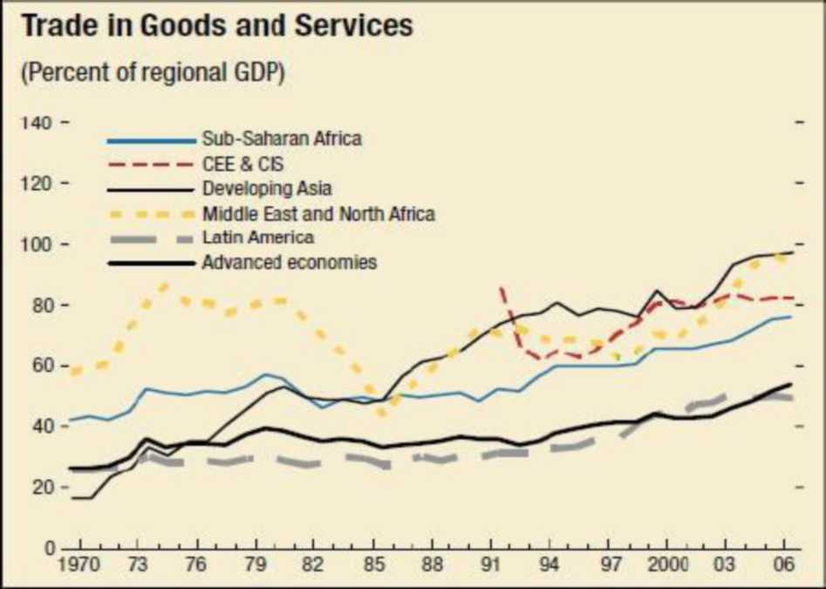

Restricting international trade—that is, engaging in protectionism—generates adverse consequences for a country that undertakes such a policy. For example, tariffs raise the prices of imported goods, harming consumers, many of which may be poor. Protectionism also tends to reward concentrated, well-organized and politically-connected groups, at the expense of those whose interests may be more diffuse (such as consumers). It also reduces the variety of goods available and generates inefficiency by reducing competition and encouraging resources to flow into protected sectors.

Developing countries can benefit from an expansion in international trade. Ernesto Zedillo, the former president of Mexico, has observed that, "In every case where a poor nation has significantly overcome its poverty, this has been achieved while engaging in production for export markets and opening itself to the influx of foreign goods, investment, and technology."⁴And the trend is clear. In the late 1980s, many developing countries began to dismantle their barriers to international trade, as a result of poor economic performance under protectionist policies and various economic crises. In the 1990s, many former Eastern bloc countries integrated into the global trading system and developing Asia—one of the most closed regions to trade in 1980—progressively dismantled barriers to trade. Overall, while the average tariff rate applied by developing countries is higher than that applied by advanced countries, it has declined significantly over the last several decades.

The implications of globalized financial markets
The world's financial markets have experienced a dramatic increase in globalization in recent years. Global capital flows fluctuated between 2 and 6 percent of world GDP during the period 1980-95, but since then they have risen to 14.8 percent of GDP, and in 2006 they totaled $7.2 trillion, more than tripling since 1995. The most rapid increase has been experienced by advanced economies, but emerging markets and developing countries have also become more financially integrated. As countries have strengthened their capital markets they have attracted more investment capital, which can enable a broader entrepreneurial class to develop, facilitate a more efficient allocation of capital, encourage international risk sharing, and foster economic growth.

Cross-Border Assets and Liabilities (Percent GDP)
Data series begin in 1995 for central and eastern Europe and the Commonwealth of Independent States.
Yet there is an energetic debate underway, among leading academics and policy experts, on the precise impact of financial globalization. Some see it as a catalyst for economic growth and stability. Others see it as injecting dangerous—and often costly—volatility into the economies of growing middle-income countries.
A recent paper by the IMF's Research Department takes stock of what is known about the effects of financial globalization. The analysis of the past 30 years of data reveals two main lessons for countries to consider.
First, these pictures support the view that countries must carefully weigh the risks and benefits of unfettered capital flows. The evidence points to largely unambiguous gains from financial integration for advanced economies. In emerging and developing countries, certain factors are likely to influence the effect of financial globalization on economic volatility and growth: countries with well-developed financial sectors, strong institutions, sounds macroeconomic policies, and substantial trade openness are more likely to gain from financial liberalization and less likely to risk increased macroeconomic volatility and to experience financial crises. For example, well-developed financial markets help moderate boom-bust cycles that can be triggered by surges and sudden stops in international capital flows, while strong domestic institutions and sound macroeconomic policies help attract "good" capital, such as portfolio equity flows and FDI.

The second lesson to be drawn from them is that there are also costs associated with being overly cautious about opening to capital flows. These costs include lower international trade, higher investment costs for firms, poorer economic incentives, and additional administrative/monitoring costs. Opening up to foreign investment may encourage changes in the domestic economy that eliminate these distortions and help foster growth.

Looking forward, the main policy lesson that can be drawn from these results is that capital account liberalization should be pursued as part of a broader reform package encompassing a country's macroeconomic policy framework, domestic financial system, and prudential regulation. Moreover, long-term, non-debt-creating flows, such as FDI, should be liberalized before short-term, debt-creating inflows. Countries should still weigh the possible risks involved in opening up to capital flows against the efficiency costs associated with controls, but under certain conditions (such as good institutions, sound domestic and foreign policies, and developed financial markets) the benefits from financial globalization are likely to outweigh the risks.

Globalization, income inequality, and poverty
As some countries have embraced globalization, and experienced significant income increases, other countries that have rejected globalization, or embraced it only tepidly, have fallen behind. A similar phenomenon is at work within countries—some people have, inevitably, been bigger beneficiaries of globalization than others.

Over the past two decades, income inequality has risen in most regions and countries. At the same time, per capita incomes have risen across virtually all regions for even the poorest segments of population, indicating that the poor are better off in an absolute sense during this phase of globalization, although incomes for the relatively well off have increased at a faster pace. Consumption data from groups of developing countries reveal the striking inequality that exists between the richest and the poorest in populations across different regions.

4. EFFECT OF GLOBALIZATION ON INDIA'S ECONOMIC GROWTH
INTRODUCTION:

As a new participant in the globalization wave, India went through several structural and policy changes only in early 1990s, even if the awareness of need for opening up country's borders was started in late 1980s, when Mr. Rajiv Gandhi was at the helm of policy design. With almost 20% devaluation of the Indian rupee in 1991, the process began that for a while slowed down a little but rarely anyone was in doubt about its existence. The recent reports show that Indian economy grew at the record breaking and astonishing pace of 8% growth in real GDP in 2003-2004. The real question is how did the economy that was an "almost autarky" from 1950 to 1985 period, reached to such a realization that gains from trade are there to reap and the economic transition necessary for globalization is a pre- condition for wider economic growth? This Term paper attempts to investigate if globalization is a cause of India's economic growth and if the new culture of trade policy change in India is there permanently or temporarily.

It is organized as follows: Section 1 makes the survey of trade policy in period 1950 to 1985; Section 2 summarizes the economic changes in period 1985 to 2005 with special focus on the liberalization attempt in 1991 and its aftereffects. Section 3 summarizes results and makes a conclusion. In general it is not very hard to prove that even a limited attempt of globalization has benefited Indian economy in the best possible way. As it is argued numerous times in other circles and by other economists the drive of liberalization has to pick up the speed for better and faster gains for the economy.

Quantitative Analysis TABLE 1

India's Trade: 1965-1985

1965 1966 | Merchandise Exports  129.4 139.3 | Services Exports  62.1 69.1 | Merchandise Imports  125.3 146.5 | Services Imports  57.5 66.2 | Trade Balance  4.9 -8.6
1967 | 98.9 | 74.8 | 152.1 | 73.2 | -57.3
1968 | 82.5 | 67.0 | 130.6 | 63.0 | -51.2
1969 | 107.1 | 69.3 | 107.0 | 56.8 | .9
1970 | 146.2 | 85.1 | 143.5 | 71.3 | 2.1
1971 | 150.8 | 97.2 | 200.6 | 85.0 | -49.0
1972 | 191.7 | 99.8 | 215.5 | 84.0 | -25.8
1973 | 291.0 | 118.9 | 326.0 | 93.2 | -16.2
1974 | 329.4 | 140.7 | 476.7 | 125.3 | -160.4
1975 | 306.5 | 182.5 | 441.9 | 118.3 | -102.7
1976 | 402.0 | 172.5 | 427.9 | 117.2 | -22.8
1977 | 512.6 | 212.1 | 564.7 | 149.8 | -48.3
1978 | 640.3 | 262.0 | 618.4 | 192.1 | 18.9
1979 | 779.6 | 292.8 | 754.1 | 253.5 | -21.2
1980 | 919.8 | 279.8 | 899.9 | 262.8 | -79.1
1981 | 896.4 | 302.8 | 925.5 | 282.0 | -147.9
1982 | 685.5 | 340.6 | 837.6 | 308.5 | -263.2
1983 | 742.0 | 342.5 | 721.6 | 280.7 | -56.9
1984 | 743.2 | 347.1 | 756.6 | 310.9 | -131.3
1985 | 814.0 | 394.3 | 814.3 | 362.9 | -115.1

(All figures are expressed in millions of US dollars at the current prices.)
One of the reasons for this retarded growth in Indian trade was the disoriented trade policy. There was even a problem of assigning priority to industries for importing necessary parts and raw materials. As Bhagwati-Desai put it, " It was not surprising, therefore, that the agencies involved in determining industry-wise allocation fell back on vague notions of "fairness", implying pro rata allocations with reference to capacity installed or employment, or shares defined by past import allocations and similar other rules of thumb without any rationale.

The hardship experienced by this virtual "closed economy" was no more evident than in early 1970s when the economy went through numerous shocks. The poor monsoons created agricultural production short-fall leading to severe droughts in some parts of the country. This put pressure on the industrial production which was not progressing very well in the first place. Due to the additional burden exerted by the Indo-Pakistan War of 1971, the economy started suffering miserably. Rationing of necessities was common and criminal elements made a heyday by hoarding. The political opposition parties made life miserable for Indira Gandhi government which had a little choice but to blame all starvation on foreign elements. In 1973, came the OPEC oil price shock and the things really went out of control. While country had no reserves to pay for imported oil, the import bill was growing very fast and export earnings were sluggish. See Table 1 figures for 1973 when imports increased from $191.7 million to $291 million and again in 1976 went up to $402 million. Political parties were extremely active.

But economically there was no way out. The protectionism was to the highest level. Consider the 350% import tariff rate on automobiles and average tariff rate of 152%. Domestic industries were well protected that they loved being monopolists and had no inclination for technological innovation. The maturity stage, that was supposed to have taken place according to the famous Infant Industry Argument has never arrived. Strict foreign exchange controls were not only required but were very necessary to stop illegal foreign currency and gold smuggling transactions. It was an administrative nightmare where rent seeker made merry and black market constituted half of the official economy. Academicians learned several lessons of how protectionism can ruin the economy and policy makers watched economy reaching to a real low point while they searched for the solutions.

To top the political chaos, the ruling party declared emergency restricting many a freedoms and ruthlessly putting anyone in jail, who gave even a hint of "Anti-governmental activity". The country definitely needed a magic for rapid economic growth which could have silenced the political "t rouble makers".

In early 1980s the monsoon god was nice to India. While agricultural sector that was in desperate need to prosper, received a big boost, the industrial sector invented few new technological advances and grew much more rapidly than before. India also realized that she can do much better in service sector. All in all, the economy started prospering at a slow rate but definitely much better than in 1970s. The need for opening up the economy was felt more keenly by Rajiv Gandhi's government and some reductions in tariff rates were activated in early 1980s. But the real support for globalization, liberalization and reduction in protectionism came in late 1980s.

Table 2
 |  | Macroeconomic Performance in Post 1991 Years
Year  1991 |  | Real GDP Growth  .96 | Inflation  Rate  8.9 |  | Interest  Rate  17.88 |  | Unemployment No. in Millions  36.3 |  | Money Supply Billions of Rs  1046.1
1992 |  | 2.3 | 13.7 |  | 18.92 |  | 36.75 |  | 1120.9
1993 |  | 1.5 | 10.1 |  | 16.25 |  | 36.27 |  | 1330.2
1994 |  | 5.9 | 8.4 |  | 14.75 |  | 36.69 |  | 1695.0
1995 |  | 7.3 | 10.9 |  | 15.46 |  | 36.74 |  | 1883.5
1996 |  | 7.3 | 7.7 |  | 15.96 |  | 37.43 |  | 2148.9
1997 |  | 7.8 | 6.4 |  | 13.83 |  | 39.14 |  | 2419.3
1998 |  | 6.5 | 4.8 |  | 13.54 |  | 40.01 |  | 2703.5
1999 |  | 6.5 | 6.9 |  | 12.54 |  | 40.0 |  | 3161.2
2000 |  | 6.1 | 3.3 |  | 12.29 |  | 40.34 |  | 3495.9
2001 |  | 4.0 | 7.1 |  | 12.08 |  | 41.99 |  | 3846.0
2002 |  | 6.2 | 4.7 |  | 11.92 |  | 42.36 |  | 4318.6
2003 |  | 5.5 | 5.1 |  | 11.50 |  | 43.10 |  | 4822.3
2004 |  | 8.0 | 4.5 |  | 10.60 |  | 42.50 |  | 5402.3
 |  | (IMF'S International Financial Statistics Yearbook, 2003.)
Table 3
International Trade Performance Post 1991 Years
 | Exports |  |  | Imports |  | BOT |  | Exchange rate
 | In billions of US dollars for 3 columns |  |  |  |  |  |  | Rs/SDR
1991 | 18.09 |  |  | 21.08 |  | 4.01 |  | 36.95
1992 | 20.01 |  |  | 22.93 |  | 4.71 |  | 36.02
1993 | 22.01 |  |  | 24.1 |  | 3.48 |  | 43.10
1994 | 25.52 |  |  | 29.67 |  | 6.31 |  | 45.81
1995 | 31.23 |  |  | 37.95 |  | 10.21 |  | 52.29
1996 | 33.73 |  |  | 43.78 |  | 13.98 |  | 51.66
1997 | 35.20 |  |  | 45.73 |  | 13.36 |  | 52.99
1998 | 34.07 |  |  | 44.82 |  | 13.60 |  | 59.81
1999 | 36.87 |  |  | 45.55 |  | 11.44 |  | 59.69
2000 | 43.13 |  |  | 55.32 |  | 13.77 |  | 60.91
2001 | 43.82 |  |  | 50.53 |  | 5.97 |  | 60.54
2002 | 52.71 |  |  | 51.41 |  | 7.58 |  | 65.29
2003 | 63.45 |  |  | 61.42 |  | 8.69 |  | 67.27
2004 | 65.09 |  |  | 77.03 |  | 13.37 |  | 68.88
(Source: IMF's International Financial Statistics Year book, 2003)

It shows the drastic turnaround of the economy in 1990s in terms of international trade patterns. While the exports increased drastically, the opening of the borders and reduction in tariff rates also allowed the imports to go up. The balance of trade figures were in a manageable amount (almost always less that $14 billion).
What is interesting to point out is that the "non-oil" imports and exports showed a positive balance of trade for the Indian economy since year 2000. Hence oil imports formed the major drain on the foreign reserves and constituted the main reason for balance of trade deficit. While the Services sector picked the exports considerably, important raw material imports have also grown significantly. One of the major developments reported in April 2005 was that software exports from India's hi-tech hub, Bangalore rose more than 52 percent to $6 billion. (Times of India, April 28, 2005). However any economic spurt is not without a political controversy and Indian economic growth is not an exception. Political skeptics have pointed out the increased inequality of income as an unwanted result of the globalization. Some politicians (especially leftists and socialists) have also complained about the increased salaries of computer scientists and information technologists. The "great digital divide" has become somewhat of a worry for some researchers. However, as Bhagwati (2004) has recently shown the globalization process has more benefits than costs and therefore needs to be supported to the fullest extent. In fact the "free trade for the whole world" scenario is based on the validity of globalization by all policy makers.

Education Destinations: The Globalization of Higher Education

More and more students are choosing to pursue their higher education in foreign countries. In some cases, this trend has created significant economic impact; hence, more and more countries are looking to attract foreign students to their institutions of higher learning.

Despite the lucrative nature of catering to foreign students, this trend also has worried some social effects.
Figure 1. Total, Undergraduate, and Graduate Enrollment of Foreign Students (thousands): 1954-55 to 2005-06
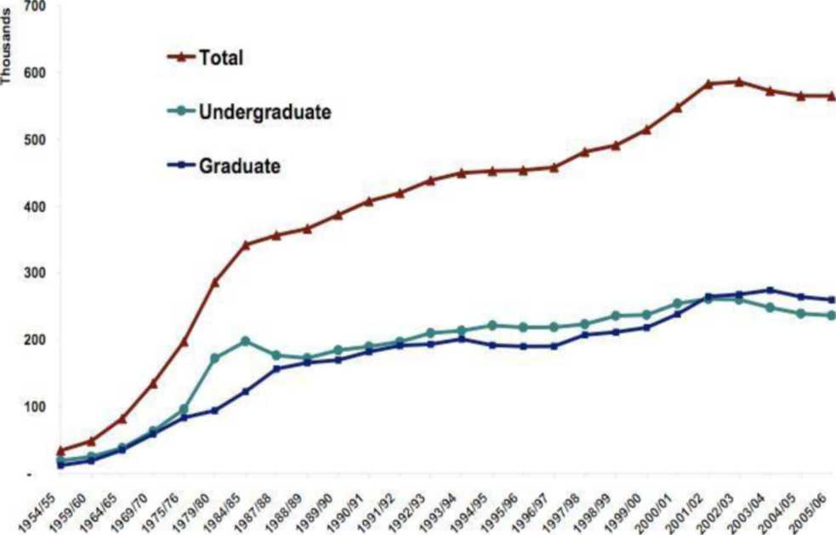
Source: C'eated tor the Migration Information Scarce. Data a^{r}e from tie nstrtute of International Education. Open Doors 2006: Reocrt on nternatonal Edjcational Excnange. New Yoht. NY: 2006. Table "internatonal Students by Academic Levei. Selected Years '954/55 -2005rt)6." available at http:/>',opendoors.iienetwort.org,,'?p-B9207.

One particularly nasty side-effect is the mistreatment of foreign students. The late 2009-early 2010 spate of attacks on Indian students in Australia is one such example. Tensions between Australia and the Indian government reached an all-time high; the Indian media published a cartoon likening the Australian response to that of the Ku Klux Klan, provoking a fierce reaction from the Australian government.

Following on this incident and similar trends worldwide, this news analysis profiles current developments in international education and examines local impacts created by the influx of foreign students.
5. The future of globalization

Like a snowball rolling down a steep mountain, globalization seems to be gathering more and more momentum. And the question frequently asked about globalization is not whether it will continue, but at what pace.

A disparate set of factors will dictate the future direction of globalization, but one important entity—sovereign governments—should not be overlooked. They still have the power to erect significant obstacles to globalization, ranging from tariffs to immigration restrictions to military hostilities. Nearly a century ago, the global economy operated in a very open environment, with goods, services, and people able to move across borders with little if any difficulty. That openness began to wither away with the onset of World War I in 1914, and recovering what was lost is a process that is still underway. Along the process, governments recognized the importance of international cooperation and coordination, which led to the emergence of numerous international organizations and financial institutions (among which
the IMF and the World Bank, in 1944).

Indeed, the lessons included avoiding fragmentation and the breakdown of cooperation among nations. The world is still made up of nation states and a global marketplace. We need to get the right rules in place so the global system is more resilient, more beneficial, and more legitimate. International institutions have a difficult but indispensable role in helping to bring more of globalization's benefits to more people throughout the world. By helping to break down barriers—ranging from the regulatory to the cultural—more countries can be integrated into the global economy, and more people can seize more of the benefits of globalization.

STEPS FOR GOING GLOBAL

As with any sound business plan, the first step is doing your homework. Here are ten action steps for taking on the world:
- Conduct market research to identify your prime target markets.
- Search out the data you need to predict how your product will sell in a specific geographic location.
- Update your database rigorously with a view to focusing more closely on those products or services which are in demand and dropping those which are not.
- Articulate your business plan for accessing global markets.
- Get companywide commitment.
- Build a web site and implement your international plan sensibly.
- Factor in a two year lead time for world market penetration.
- Make personal contact with your new targets armed with culture specific information and courtesies, professionalism and consistency.
- Value the relationship more than the deal; the individual is more important than closing the deal under discussion.
- Welcome the unknown.

- Advantages of Globalization:

Globalization has several advantages on the
—Economic, —Cultural, —Technological, and
- Social and some other fronts.

Globalization means increasing the
- Interdependence,
- Connectivity and
- Integration on a

Global level with respect to the
- Social,
- Cultural,
- Political,
- Technological,
- Economic and
- Ecological levels

Advantages of Globalization
- Goods and people are transported with more easiness and speed
- The possibility of war between the developed countries decreases
- Free trade between countries increases
- Global mass media connects all the people in the world
- As the cultural barriers reduce, the global village dream becomes more realistic
- There is a propagation of democratic ideals
- The interdependence of the nation-states increases
- As the liquidity of capital increases, developed countries can invest in developing ones
- The flexibility of corporations to operate across borders increases
- The communication between the individuals and corporations in the world increases
- Environmental protection in developed countries increases
- Increased free trade between nations
- Increased liquidity of capital allowing investors in developed nations to invest in developing nations
- Corporations have greater flexibility to operate across borders
- Global mass media ties the world together
- Increased flow of communications allows vital information to be shared between individuals and corporations around the world
- Greater ease and speed of transportation for goods and people
- Reduction of cultural barriers increases the global village effect
- Spread of democratic ideals to developed nations
- Greater interdependence of nation-states
- Reduction of likelihood of war between developed nations
- Increases in environmental protection in developed nation

However, such doubts are futile as globalization is a positive-sum chance in which the skills and technologies enable to increase the living standards throughout the world. Liberals look at globalization as an efficient tool to eliminate penury and allow the poor people a firm foothold in the global economy. In two decades from 1981 to 2001, the number of people surviving on $1 or less per day decreased from 1.5 billion to 1.1 billion. Simultaneously, the world population also increased. Thus, the percentage of s uch people decreased from 40% to 20% in such developing countries.

7. Disadvantages of Globalization
- Increased flow of skilled and non-skilled jobs from developed to developing nations as corporations seek out the cheapest labor
- Increased likelihood of economic disruptions in one nation effecting all nations
- Corporate influence of nation-states far exceeds that of civil society organizations and average individuals
- Threat that control of world media by a handful of corporations will limit cultural expression
- Greater chance of reactions for globalization being violent in an attempt to preserve cultural heritage
- Greater risk of diseases being transported unintentionally between nations

— Spread of a materialistic lifestyle and attitude that sees consumption as the path to prosperity
- International bodies like the World Trade Organization infringe on national and individual sovereignty
- Increase in the chances of civil war within developing countries and open war between developing countries as they vie for resources
- Decreases in environmental integrity as polluting corporations take advantage of weak regulatory rules in developing countries

8. Recommendations

Globalization is not better for developing countries because the developing counties have less capital, insufficient, infrastructure, low technology and unskilled manpower. Due to all these reasons developing countries can not adopt the globalization structure.
In a globally environment there is tough competition tough competition of local producers to struggle. Because the larger producers is in market and capture the whole market. Many persons have a good structure but they have not enough finance to compete the multinational organizations.
There is trade deficit faced by the developing countries. This is the major problem. And due to that problem many countries is not in favorable condition to compete with developed countries.
Globalization open the new horizons for investment in any other country either the country developed or not. Availability of waste market is a big advantage for multinational companies to explore the new markets.
Transfer of technology is a big advantage of globalization for the developing countries so it is essential for these countries adopt and enjoy the benefit.
Globalization is the threat for small and medium entrepreneurs so it is necessary to protect that industry.
Threat of decrease in government revenues in shape of taxes is another problem so it is necessary to avoid and draw new policies.
Protest against globalization is another issue so it is necessary to protect the consumers, small industries and developing and poor countries from the risks and develop new policies to avoid above mentioned factors.
Globalization also helpful for the different economies to agree on a specific single currency so the balance is maintained. Loan also provided by the companies to finance at international level and there is no more restriction for small and medium entrepreneur's to obtain loans from the financial institutions.

9. CONCLUSION

This Term Paper is comprised of the effects of globalization on firms. The first thing advances prior knowledge on globalization and business by empirically investigating how this phenomenon affects firm performance. They explore the role of firms' cooperation in alliances in enhancing their performance amid globalization by specifically focusing on co-marketing alliances and international marketing performance of firms. A particular emphasis is paid to this type of alliance since superior marketing is crucial for firms to build a sustainable source of unique competitive advantage. Such advantage eventually enables firms to achieve long-run success in a hypercompetitive terrain under globalization. While this project also proposes a conceptual framework relating globalization effects to alliance cooperation and firm performance. Given that globalization is a complex phenomenon, there is a scarcity of empirical research investigating its effects on businesses. Hence, there are several significant contributions of this term paper. First, the effects of globalization on firms are classified into two key dimensions—global market opportunities and global market threats— based on an extensive review of scattered literature on the topic. Second, these major effects are operational zed and empirically tested in two conceptual models to examine the relationships among these effects, cooperation in alliances, and firm performance. Third, literature on international business, strategic management, and marketing are integrated to address the effects of globalization on firms' marketing conduct and outcomes. The first thing discussed in this term paper is how globalization affects firms. It draws from environment-organization literature. Building on this stream of research, macro environment such as globalization represents a context in which organizational characteristics and outputs are strongly shaped. For this reason, this term paper attempts to demonstrate and address how globalization influences firm performance.

The term paper proposes a conceptual framework to investigate relationships among globalization effects, degree of cooperation in co-marketing alliances, and international marketing performance. This term paper focuses on relationships between globalization effects and alliances because past research often mentions that globalization drives more collaboration and alliance participation.

Thus, this term paper explores how firms with international marketing activities can enhance their performance in the global marketplace through increased cooperation in co-marketing alliances. Building on market power perspective and transaction cost economics; this term paper proposes that increased global market threats, including competitive threats and market uncertainty, will encourage more cooperation in alliances while global market opportunities will not. While transaction costs economics considers alliances as a strategy enabling firms to expand their strategic capabilities, market power perspective regards alliances as a means to reduce competition and minimize uncertainty evoked by globalization.

Such cooperation eventually increases international marketing effectiveness of firms engaging in co-marketing alliances. Whereas an increase in cooperation is influenced by higher global market threats (i.e., both competitive threats and uncertainty), it is not affected by global market opportunities. The absence of any effect of global market opportunities on alliance cooperation can be attributed to the fact that ample opportunities in the markets may result in the lack of collaboration among firms. Moreover, it is found that increased cooperation in co-marketing alliances helps firms enhance international marketing effectiveness but not efficiency. Since higher expenses may arise from such cooperative attempts, efficiency becomes difficult to realize. In sum, these results validate globalization-alliance literature by showing that globalization actually drives more cooperation among firms.

Managers should be prepared to cope with these diverse effects by capitalizing on global market opportunities while carefully managing the inherent threats. Alliance participation and cooperation presents a viable option for firms to navigate successfully in this new competitive landscape. From both theoretical and practical perspectives, globalization is a complex phenomenon. The three manuscripts included in this dissertation are among a few empirical studies emphasizing the effects of globalization on firms. Given that globalization is multifaceted and only a few key dimensions of its effects were explored here, many issues remain to be addressed.

10. Bibliography and References -

I've taken all the information from official sites of govt. Of India and Indian companies and few data from books, online journals and news paper which are given below-
Websites
www.globalization101 .org www.globalpolicy.org/globalization.html www.economywatch.com > Economy
Articles

www.tradechakra.com > Indian Economy -
eac.gov.in/.../55GLOBAUZATION%o20AND%o20CHALLENGES°/o20BEFORE°/o... www.eurojournals.com/IRJFE%206%20goyal.pd economics.about.com/.../globalization trade/l/aaglobalization.htm -www.fibre2fashion.com/.../8/.../impact-of-globalization1.asp -www.indiastudychannel.com > ... > Education -www.eurojournals.com/IRJFE%206%20goyal.pdf -www.busiessstandard.com
www.thehindhu.com www.onlinejournal.com

Newspaper
- The Hindu, published by B.C.Acherakar ('Nov '09) Business standard (21 october 09)
Books
- International business environment by 'Robert' Published by Pearson publication
- International business by 'Stephen' Publishes by Tata Mc'graw Publication

MORE FREE TERM PAPERS ON SITE: www.maturski.org

